**Front End Engineering-II**

                                                                  Project Report

Semester-IV (Batch-2022)

Online Shopping Site

**Supervised By:**  **Submitted By:**

Mr. RAVEESH SAMKARIA                Shreya Tewari

2210990839

G13A

**Department of Computer Science and Engineering**

**Chitkara University Institute of Engineering & Technology,**

**Chitkara University, Punjab**

**ABSTRACT**

This project presents the development of a comprehensive online shopping site utilizing HTML, CSS, and React JS. The platform is designed to deliver an intuitive and seamless shopping experience for users, incorporating modern web development technologies to ensure responsiveness, performance, and scalability.

The site boasts a clean, modern design with an easy-to-navigate layout, ensuring an optimal user experience across various devices. Leveraging CSS and responsive design principles, the site adapts seamlessly to different screen sizes, providing a consistent and accessible experience on desktops, tablets, and mobile devices. React JS facilitates the creation of dynamic, interactive user interfaces, allowing for real-time updates and efficient state management. This ensures that product listings, shopping carts, and user interactions are handled smoothly. Advanced search functionality and filtering options enable users to quickly find and sort products based on categories, price ranges, ratings, and other criteria.

n intuitive shopping cart system allows users to easily add, remove, and update products. The streamlined checkout process ensures secure and efficient transactions, supporting multiple payment gateways. While this abstract focuses on the front-end development using HTML, CSS, and React JS, the site is designed to integrate seamlessly with backend services and APIs for product data, user management, and order processing. Employing best practices in coding, such as code splitting, lazy loading, and efficient state management, the site ensures fast load times and a responsive user interface. Ensuring compatibility across major web browsers, the site is tested to provide a consistent experience regardless of the user's browser choice.

This abstract outlines the key aspects and features of the online shopping site project, highlighting the technologies used and the benefits provided to users.

**TABLE OF CONTENT:**

|  |  |  |
| --- | --- | --- |
| Serial No. | Section | Page No. |
| 1 | Introduction | 4-5 |
| 2 | Problem Definitions and Requirements | 6-7 |
| 3 | Proposed Design | 8-10 |
| 4 | Results | 11-43 |
| 5 | References | 44 |

**1. INTRODUCTION**

**1.1 Background**

The advent of the internet has revolutionized the way people shop, leading to a significant shift from traditional brick-and-mortar stores to online shopping platforms. This transformation is driven by the convenience, variety, and competitive pricing offered by online stores. As consumers increasingly rely on digital solutions for their shopping needs, the demand for efficient, user-friendly, and secure e-commerce websites has surged. Developing a robust online shopping site using modern web technologies such as HTML, CSS, and React JS is crucial to meet these evolving consumer expectations.

**1.2 Objectives**

The primary objective of this project is to design and implement an online shopping site that delivers an optimal user experience. The specific goals include:

* **Creating a Responsive and Intuitive Interface:** To develop a visually appealing and easy-to-navigate site that provides a consistent experience across different devices and screen sizes.
* **Enhancing User Interaction:** To leverage React JS for building dynamic and interactive user interfaces that offer real-time updates and seamless navigation.
* **Implementing Secure User Authentication:** To ensure that user data is protected through secure login and registration processes.
* **Facilitating Efficient Shopping and Checkout Processes:** To design an intuitive shopping cart system and a streamlined checkout process that supports various payment methods.
* **Ensuring High Performance and Scalability:** To employ best practices in web development for optimizing performance and ensuring the site can handle increasing traffic and data loads.
* **Integrating with Backend Services:** To provide a foundation that can be easily integrated with backend APIs and services for product management, user data handling, and order processing.

**1.3 Significance**

The significance of this project lies in its ability to address the needs of modern consumers and businesses. By developing a sophisticated online shopping site, the project aims to:

* **Enhance Customer Convenience:** Offering a platform that allows users to shop from the comfort of their homes, providing detailed product information, customer reviews, and various payment options.
* **Expand Business Reach:** Enabling businesses to reach a broader audience beyond their physical location, tapping into new markets and customer segments.
* **Boost Sales and Revenue:** Facilitating a smooth and enjoyable shopping experience can lead to increased customer satisfaction, repeat purchases, and higher sales conversions.
* **Showcase Technological Proficiency:** Demonstrating the effective use of HTML, CSS, and React JS to create a high-quality, scalable, and maintainable e-commerce solution.
* **Set a Benchmark for Future Projects:** Establishing a strong foundation for future enhancements, such as the integration of advanced features like AI-driven recommendations, augmented reality shopping, and personalized user experiences.

**2. PROBLEM DEFINITION AND REQUIREMENTS**

**2.1 Problem Definition:**

The contemporary online shopping landscape is plagued with several issues that detract from the user experience and operational efficiency of e-commerce platforms. These problems can be broadly categorized into inconsistent user experiences, poor website performance, limited interactivity, security vulnerabilities, and scalability challenges. Specifically, many e-commerce sites struggle to deliver a seamless and enjoyable shopping experience across various devices, suffer from slow load times, lack real-time dynamic content, and fail to protect user data adequately. Moreover, inefficient checkout processes and the inability to scale with growing business demands further exacerbate these issues. Therefore, there is a pressing need for an online shopping site that effectively utilizes modern web technologies, namely HTML, CSS, and React JS, to overcome these shortcomings.

**2.2 Requirements:**

* **User Interface and Navigation:** Develop a clean, intuitive, and responsive user interface that adapts seamlessly to various devices and screen sizes.Implement clear and consistent navigation menus to facilitate easy browsing and product discovery.
* **Product Catalog Management:** Design a dynamic product catalog that supports the addition, removal, and updating of products.Enable product categorization, filtering, and sorting based on attributes like price, popularity, and user ratings.
* **Search Functionality:** Implement a robust search feature that allows users to quickly find products by keywords, categories, and filters.
* **User Authentication:** Create secure user registration and login functionalities with data encryption to protect user information.Include password recovery options and user profile management.
* **Shopping Cart:** Develop a shopping cart system that allows users to add, remove, and update products.Display real-time updates of the cart contents and total cost.
* **Checkout Process:** Implement a streamlined, multi-step checkout process that supports various payment methods.Ensure secure transactions and order confirmation notifications.
* **Order Management:** Provide users with order history and tracking capabilities.Allow users to view and manage their orders from their profile.
* **User Reviews and Ratings:** Enable users to leave reviews and ratings for products.Display aggregated ratings and reviews on product pages.

1. **PROPOSED DESIGN AND METHODOLOGY**

**3.1 PROPOSED DESIGN**

* **Frontend Development:**
* **HTML & CSS:** Use HTML for structuring the web pages and CSS for styling. Employ CSS frameworks like Bootstrap or Tailwind CSS for responsive design and faster development.
* **React JS:** Utilize React JS to build dynamic and interactive user interfaces. Components in React will be used to modularize the UI, ensuring maintainability and scalability.
* **Component Structure:**
* **Header & Navigation:** A fixed header component containing the logo, navigation links, and a search bar.
* **Product Listing:** A product listing component that dynamically displays products with filtering and sorting options.
* **Product Detail:** A detailed product view component displaying product images, descriptions, reviews, and ratings.
* **Shopping Cart:** A shopping cart component allowing users to add, remove, and update products.
* **User Authentication:** Components for registration, login, and user profile management.
* **Checkout Process:** Components to handle the multi-step checkout process, including address input, payment options, and order review.
* **Footer:** A footer component with additional links and information.

**3.2 Methodology**

* **Project Setup:**
* Initialize the project using Create React App.
* Set up version control with Git and create a repository on GitHub.
* **Component Development:**
* **Header & Navigation:** Develop the header and navigation components with links to various sections of the site.
* **Home & Product Pages:** Create the main home page and product listing pages, incorporating filters and search functionality.
* **Product Details:** Build the product detail component to display detailed information about each product.
* **Shopping Cart:** Implement the shopping cart component with add, remove, and update functionalities.
* **Authentication:** Develop user authentication components, ensuring secure login and registration processes.
* **Checkout:** Create a multi-step checkout process, integrating payment options and order review.
* **Styling & Responsiveness:**
* Use CSS and CSS frameworks to style the components.
* Ensure the design is responsive, adjusting layouts and elements to fit various screen sizes.
* **State Management & Data Flow:**
* Implement global state management using React Context API or Redux.
* Ensure efficient data flow between components, minimizing unnecessary re-renders.

**3.3** **FILE STRUCTURE**

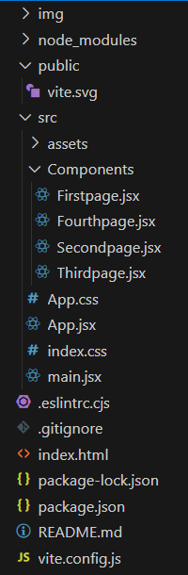

Fig. File Structure

**4. RESULTS**

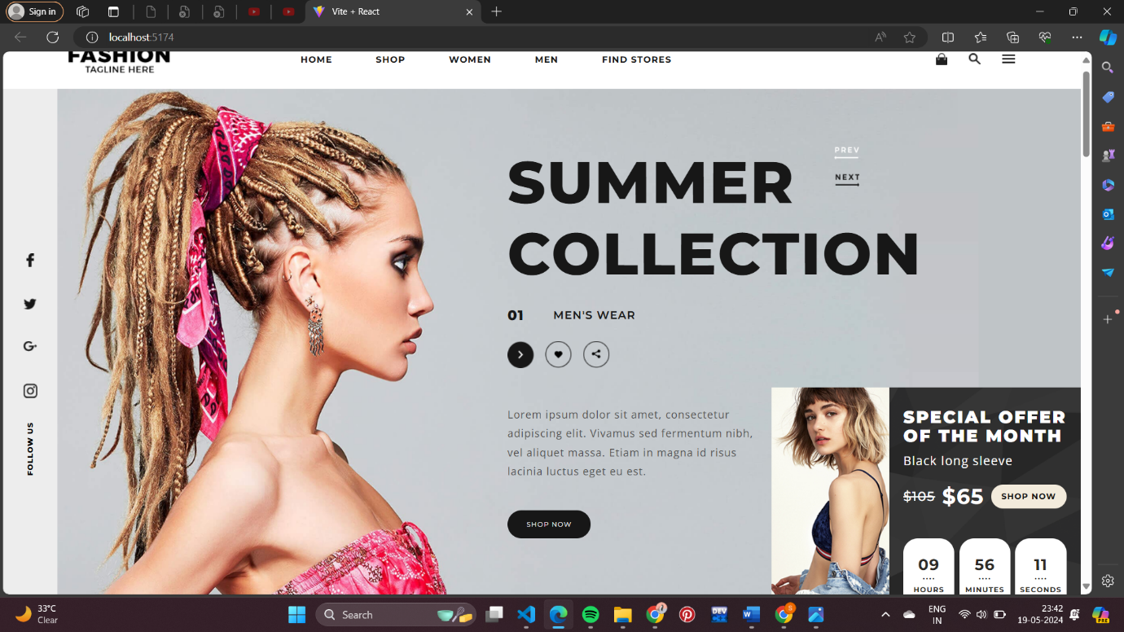

Fig.1.1 First Page

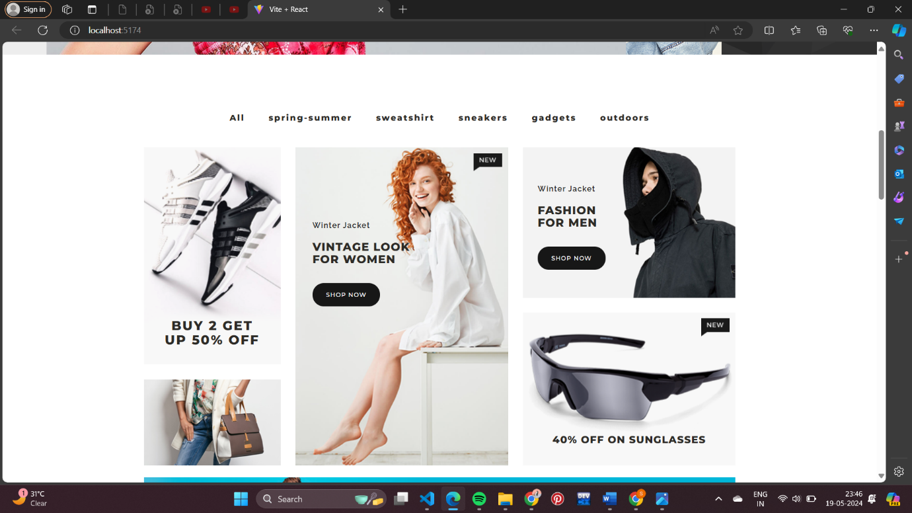

Fig.1.2 Second Page

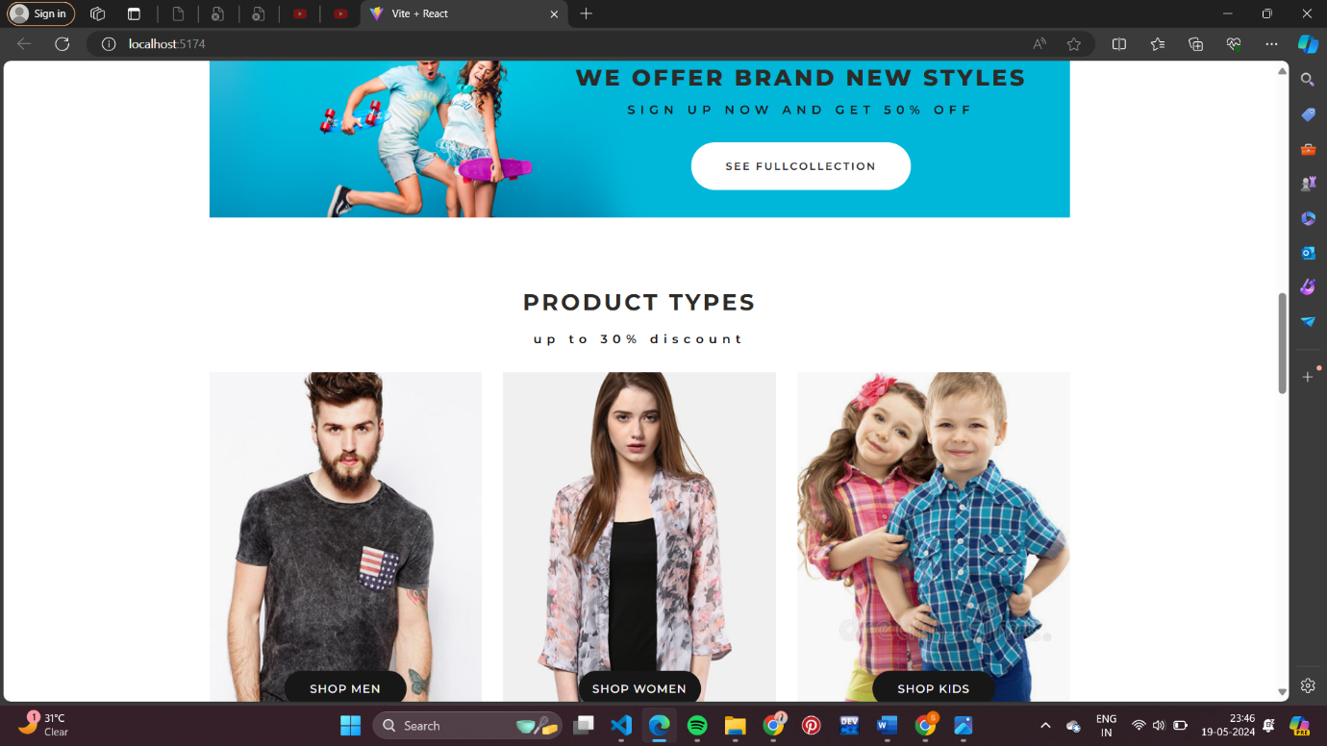

Fig.1.3 Third Page

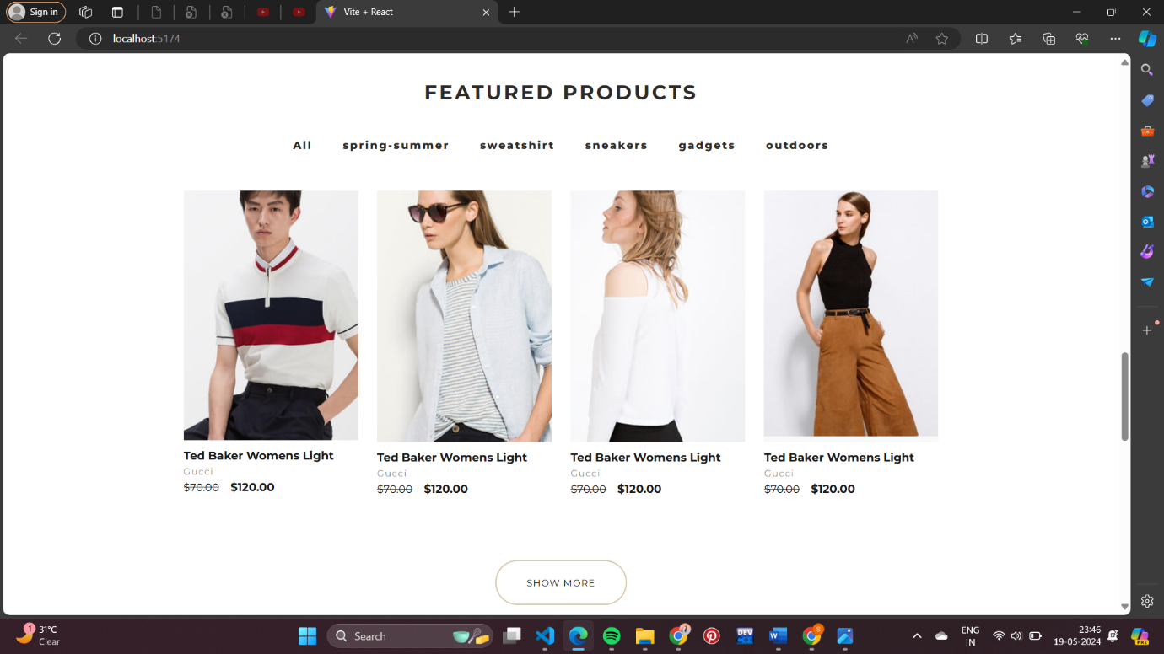

Fig.1.4 Fourth Page

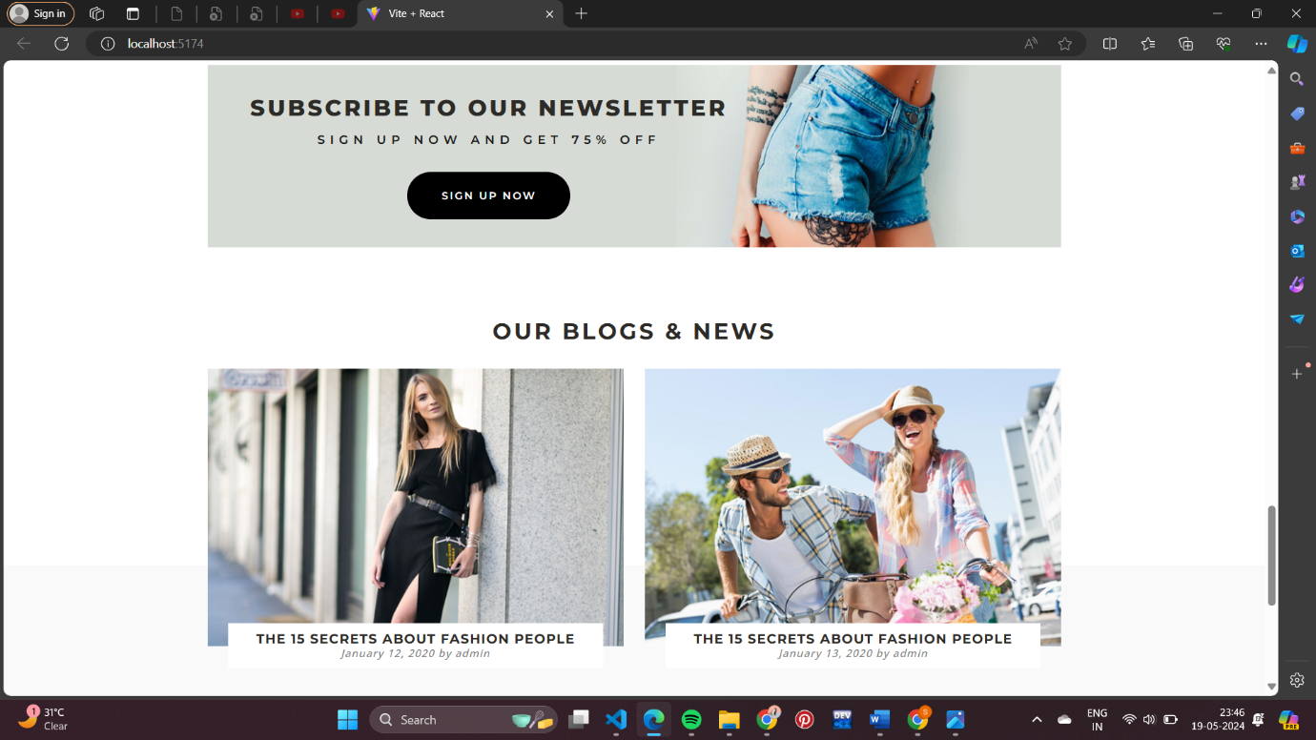

Fig.1.5 Fifth Page

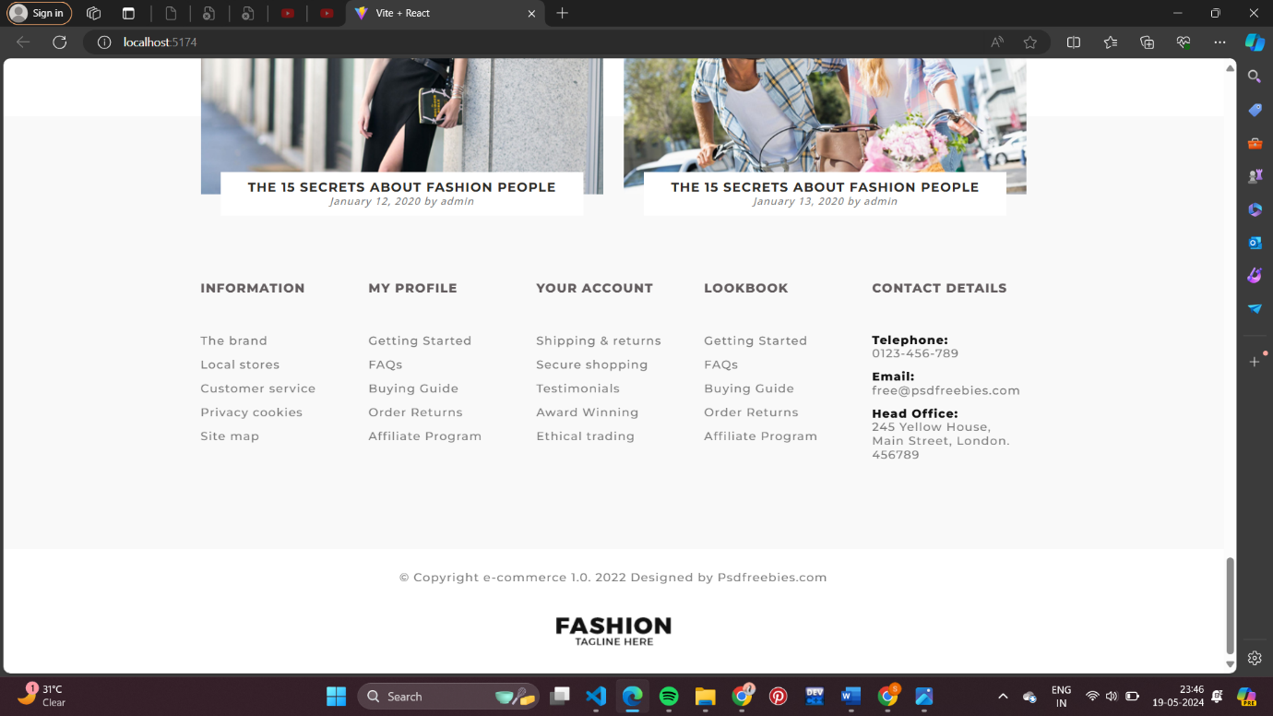

Fig.1.6 Sixth Page

**4.2 Code**

 import React, { useState } from "react";

const First =()=>{

    const [isActive, setIsActive] = useState(false);

    const toggleMenu = () => {

        setIsActive(!isActive);

    };

    return(

        <>

  <div className="menu">

    <div className="logo">

      <img src="img/logo.png" alt="" />

      <div className={`header ${isActive ? "active" : ""}`}>

        <ul className="sub-menu">

          <li>

            <a href="">HOME</a>

          </li>

          <li>

            <a href="">SHOP</a>

          </li>

          <li>

            <a href="">WOMEN</a>

          </li>

          <li>

            <a href="">MEN</a>

          </li>

          <li>

            <a href="">FIND STORES</a>

          </li>

        </ul>

      </div>

    </div>

    <div className="right">

      <div className="cart">

        <img src="img/cart.png" alt="" />

      </div>

      <div className="search">

        <img src="img/search .png" alt="" />

      </div>

      <div className="burger">

        <img className="hamburger"  onClick={toggleMenu} src="img/icon.png" alt=""  />

      </div>

    </div>

  </div>

        </>

    )

}

export default First

import React from "react";

const Second =()=>{

    return(

        <>

         <div className="slider-img">

    <div className="social">

      <li>

        <a href="#">

          <img src="img/fb.png" alt="" />

        </a>

      </li>

      <li>

        <a href="#">

          <img src="img/tw.png" alt="" />

        </a>

      </li>

      <li>

        <a href="#">

          <img src="img/g+.png" alt="" />

        </a>

      </li>

      <li>

        <a href="#">

          <img src="img/insta.png" alt="" />

        </a>

      </li>

      <li className="follow">

        <p>FOLLOW US</p>

      </li>

    </div>

    <div className="bg">

      {/* <img src="img/Slider Image.png" alt="" class="slider-img"> */}

      <div className="slider-img-txt">

        <div>

          <p>

            SUMMER <img className="prev-next" src="img/prev-next.png" alt="" />{" "}

            <br />

            COLLECTION

          </p>

        </div>

        <div className="slider-info-sale">

          <div className="slider-info">

            <div className="slider-text">

              <h1>01</h1>

              <h2>MEN'S WEAR</h2>

            </div>

            <div className="slider-icons">

              <img src="img/arrow-btn.png" alt="" />

              <img src="img/wishlist-btn.png" alt="" />

              <img src="img/share-btn.png" alt="" />

            </div>

            <div>

              <h3 className="h3">

                Lorem ipsum dolor sit amet, consectetur adipiscing elit. Vivamus

                sed fermentum nibh, vel aliquet massa. Etiam in magna id risus

                lacinia luctus eget eu est.

              </h3>

            </div>

            <button>SHOP NOW</button>

          </div>

          <div className="sale">

            <img src="img/sale-image.png" alt="" className="sale-img" />

            <div className="sale-txt">

              <div className="sale-txt-2">

                <div className="sale-offer">

                  <h1>

                    SPECIAL OFFER

                    <br />

                    OF THE MONTH

                  </h1>

                </div>

                <div className="item-price">

                  <h3>Black long sleeve</h3>

                  <div className="sale-price">

                    <h1>$105</h1>

                    <h2>$65</h2>

                    <button>SHOP NOW</button>

                  </div>

                </div>

              </div>

              <div className="main-timer">

                <div className="timer-box">

                  <h1>09</h1>

                  <h2>....</h2>

                  <h3>HOURS</h3>

                </div>

                <div className="timer-box">

                  <h1>56</h1>

                  <h2>....</h2>

                  <h3>MINUTES</h3>

                </div>

                <div className="timer-box">

                  <h1>11</h1>

                  <h2>....</h2>

                  <h3>SECONDS</h3>

                </div>

              </div>

            </div>

          </div>

        </div>

      </div>

    </div>

  </div>

        </>

    )

}

export default Second

import React from "react";

const Third =()=>{

    return(

        <>

        <div id="page-2">

    <div className="section-2">

      <ul>

        <li>

          <a href="">All</a>

        </li>

        <li>

          <a href="">spring-summer</a>

        </li>

        <li>

          <a href="">sweatshirt</a>

        </li>

        <li>

          <a href="">sneakers</a>

        </li>

        <li>

          <a href="">gadgets</a>

        </li>

        <li>

          <a href="">outdoors</a>

        </li>

      </ul>

      <div className="grid-container">

        <div className="grid-item a">

          <img src="img/shoes1.png" alt="" />

          <div className="grid-text-absolute-a">

            <h1>

              BUY 2 GET

              <br />

              UP 50% OFF

            </h1>

          </div>

        </div>

        <div className="grid-item b">

          <img src="img/whitedress.png" alt="" />

          <img className="new" src="img/new.png" alt="" />

          <div className="grid-text-absolute-b">

            <h2>Winter Jacket</h2>

            <h1>

              VINTAGE LOOK

              <br />

              FOR WOMEN

            </h1>

            <button>SHOP NOW</button>

          </div>

        </div>

        <div className="grid-item c">

          <img src="img/black hoodie.png" alt="" />

          <div className="grid-text-absolute-c">

            <h2>Winter Jacket</h2>

            <h1>

              FASHION

              <br />

              FOR MEN

            </h1>

            <button>SHOP NOW</button>

          </div>

        </div>

        <div className="grid-item d">

          <img src="img/handbag.png" alt="" />

        </div>

        <div className="grid-item e">

          <img src="img/glasses.png" alt="" />

          <img className="new" src="img/new.png" alt="" />

          <div className="grid-text-absolute-e">

            <h1>40% OFF ON SUNGLASSES</h1>

          </div>

        </div>

      </div>

    </div>

    <div className="banner">

      <img src="img/offer-styles-bg.png" alt="" />

      <div className="banner-txt">

        <h1>WE OFFER BRAND NEW STYLES</h1>

        <h2>SIGN UP NOW AND GET 50% OFF</h2>

        <button>SEE FULLCOLLECTION</button>

      </div>

    </div>

    <div className="section-3">

      <div className="headings">

        <h1>PRODUCT TYPES</h1>

        <h2>up to 30% discount</h2>

      </div>

      <div className="photo-section">

        <div>

          <div className="photo-sub-section">

            <img

              className="image span-1"

              src="img/shopmen.png"

              alt="Shop Men"

            />

            <button className="photo-section-btn">SHOP MEN</button>

          </div>

          <div className="photo-sub-section">

            <img

              className="image span-1"

              src="img/shop women.png"

              alt="Shop Women"

            />

            <button className="photo-section-btn">SHOP WOMEN</button>

          </div>

          <div className="photo-sub-section">

            <img className="image span-1" src="img/shop.png" alt="Shop" />

            <button className="photo-section-btn">SHOP KIDS</button>

          </div>

        </div>

      </div>

    </div>

    <div className="section-4">

      <div className="headings">

        <h1>FEATURED PRODUCTS</h1>

      </div>

      <ul>

        <li>

          <a href="">All</a>

        </li>

        <li>

          <a href="">spring-summer</a>

        </li>

        <li>

          <a href="">sweatshirt</a>

        </li>

        <li>

          <a href="">sneakers</a>

        </li>

        <li>

          <a href="">gadgets</a>

        </li>

        <li>

          <a href="">outdoors</a>

        </li>

      </ul>

      <div className="photo-section">

        <div>

          <div className="photo-sub-section">

            <img className="image span-1" src="img/FP-1.png" alt="Shop Men" />

            <div className="photo-sub-section-txt">

              <h1>Ted Baker Womens Light</h1>

              <h3>Gucci</h3>

              <div className="photo-sub-section-txt-price">

                <h4>$70.00</h4>

                <h5>$120.00</h5>

              </div>

            </div>

          </div>

          <div className="photo-sub-section">

            <img className="image span-1" src="img/FP-2.png" alt="Shop Women" />

            <div className="photo-sub-section-txt">

              <h1>Ted Baker Womens Light</h1>

              <h3>Gucci</h3>

              <div className="photo-sub-section-txt-price">

                <h4>$70.00</h4>

                <h5>$120.00</h5>

              </div>

            </div>

          </div>

          <div className="photo-sub-section">

            <img className="image span-1" src="img/FP-3.png" alt="Shop" />

            <div className="photo-sub-section-txt">

              <h1>Ted Baker Womens Light</h1>

              <h3>Gucci</h3>

              <div className="photo-sub-section-txt-price">

                <h4>$70.00</h4>

                <h5>$120.00</h5>

              </div>

            </div>

          </div>

          <div className="photo-sub-section">

            <img className="image span-1" src="img/FP-4.png" alt="Shop" />

            <div className="photo-sub-section-txt">

              <h1>Ted Baker Womens Light</h1>

              <h3>Gucci</h3>

              <div className="photo-sub-section-txt-price">

                <h4>$70.00</h4>

                <h5>$120.00</h5>

              </div>

            </div>

          </div>

        </div>

        <button className="SM">Show More</button>

      </div>

    </div>

    <div className="banner">

      <img src="img/newsletter-bg.png" alt="" />

      <div className="banner-txt-2">

        <h1>SUBSCRIBE TO OUR NEWSLETTER</h1>

        <h2>SIGN UP NOW AND GET 75% OFF</h2>

        <button>SIGN UP NOW</button>

      </div>

    </div>

    <div className="section-5">

      <div className="headings">

        <h1>OUR BLOGS &amp; NEWS</h1>

      </div>

      <div className="photo-section">

        <div>

          <div className="photo-sub-section">

            <img className="image span-1" src="img/BN-1.png" alt="Shop Men" />

            <div className="photo-sub-section-txt-2">

              <h1>THE 15 SECRETS ABOUT FASHION PEOPLE</h1>

              <h2>January 12, 2020 by admin</h2>

            </div>

          </div>

          <div className="photo-sub-section">

            <img className="image span-1" src="img/BN-2.png" alt="Shop Women" />

            <div className="photo-sub-section-txt-2">

              <h1>THE 15 SECRETS ABOUT FASHION PEOPLE</h1>

              <h2>January 13, 2020 by admin</h2>

            </div>

          </div>

        </div>

      </div>

    </div>

  </div>

        </>

    )

}

export default Third

import React from "react";

const Fourthpage =()=>{

    return(

        <>

         <div className="footer">

    <div className="footer-section-1">

      <div>

        <h1>INFORMATION</h1>

        <div className="col-1">

          <ul>

            <li>

              <a href="#">The brand</a>

            </li>

            <li>

              <a href="">Local stores</a>

            </li>

            <li>

              <a href="">Customer service</a>

            </li>

            <li>

              <a href="">Privacy cookies</a>

            </li>

            <li>

              <a href="">Site map</a>

            </li>

          </ul>

        </div>

      </div>

      <div className="col-1">

        <h1>MY PROFILE</h1>

        <div>

          <ul>

            <li>

              <a href="">Getting Started</a>

            </li>

            <li>

              <a href="">FAQs</a>

            </li>

            <li>

              <a href="">Buying Guide</a>

            </li>

            <li>

              <a href="">Order Returns</a>

            </li>

            <li>

              <a href="">Affiliate Program</a>

            </li>

          </ul>

        </div>

      </div>

      <div className="col-1">

        <h1>YOUR ACCOUNT</h1>

        <div>

          <ul>

            <li>

              <a href="">Shipping &amp; returns</a>

            </li>

            <li>

              <a href="">Secure shopping</a>

            </li>

            <li>

              <a href="">Testimonials</a>

            </li>

            <li>

              <a href="">Award Winning</a>

            </li>

            <li>

              <a href="">Ethical trading</a>

            </li>

          </ul>

        </div>

      </div>

      <div className="col-1">

        <h1>LOOKBOOK</h1>

        <div>

          <ul>

            <li>

              <a href="">Getting Started</a>

            </li>

            <li>

              <a href="">FAQs</a>

            </li>

            <li>

              <a href="">Buying Guide</a>

            </li>

            <li>

              <a href="">Order Returns</a>

            </li>

            <li>

              <a href="">Affiliate Program</a>

            </li>

          </ul>

        </div>

      </div>

      <div className="col-2">

        <h1>CONTACT DETAILS</h1>

        <div>

          <ul>

            <li>

              <h1>Telephone:</h1>

              <a href="tel:+0123-456-789">0123-456-789</a>

            </li>

            <li>

              <h1>Email:</h1>

              <a href="mailto:free@psdfreebies.com">free@psdfreebies.com</a>

            </li>

            <li>

              <h1>Head Office:</h1>245 Yellow House, Main Street, London. 456789

            </li>

          </ul>

        </div>

      </div>

    </div>

    <div className="footer-section-2">

      <p>© Copyright e-commerce 1.0. 2022 Designed by Psdfreebies.com</p>

      <img src="img/Logo.png" alt="" />

    </div>

  </div>

        </>

    )

}

export default Fourthpage

@import url("https://fonts.googleapis.com/css2?family=Montserrat:ital,wght@0,100..900;1,100..900&display=swap");

@import url("https://fonts.googleapis.com/css2?family=Open+Sans:wght@300;400;500;600;700;800&display=swap");

@import url("https://fonts.googleapis.com/css2?family=Raleway:ital,wght@0,100..900;1,100..900&display=swap");

* {

    margin: 0;

    padding: 0;

    font-size: 12px;

    letter-spacing: 1px;

    color: #171717;

    font-weight: 600;

    font-family: "Montserrat";

    box-sizing: border-box;

}

html {

    overflow-x: hidden;

}

button {

    cursor: pointer;

}

.menu {

    display: flex;

    align-items: center;

    justify-content: space-between;

    margin: 0 auto;

    padding: 3vh 6vw;

}

.logo {

    display: flex;

    align-items: center;

}

.logo img {

    max-width: 70%;

}

.header {

    padding-left: 10vw;

}

.header ul {

    display: flex;

    align-items: center;

    list-style: none;

}

.header li {

    list-style: none;

    cursor: pointer;

    padding: 0 2vw;

}

.header ul li a {

    text-decoration: none;

    font-size: 12px;

    letter-spacing: 1px;

    line-height: 23px;

    color: #171717;

    font-weight: 700;

    font-family: "Montserrat";

}

.burger {

    z-index: 4;

}

.right {

    display: flex;

    align-items: center;

}

.right > div {

    padding-left: 2vw;

}

.right > div img {

    cursor: pointer;

}

.slider-img {

    width: 100%;

    height: 100vh;

    display: flex;

}

.social {

    background-color: #ededed;

    display: flex;

    flex-direction: column;

    align-items: center;

    justify-content: center;

    z-index: 2;

}

.social li {

    list-style: none;

    padding: 20px 0;

}

.follow {

    width: 74px;

}

.follow p {

    font-size: 10px;

    letter-spacing: 1px;

    color: #000000;

    font-weight: 800;

    font-family: "Montserrat";

    transform: rotate(-90deg);

    padding: 20px 0;

}

.bg {

    position: relative;

    width: 100%;

    height: 100vh;

    background: #bfc4c7;

    z-index: 1;

}

.bg::before {

    content: "";

    position: absolute;

    top: 0;

    left: 0;

    width: 100%;

    height: 100%;

    background-image: url("img/Slider\ Image.png");

    background-size: cover;

    background-repeat: no-repeat;

    background-size: 95% 100%;

    transform: translateX(-5%);

    z-index: -1;

}

.slider-img-txt {

    display: flex;

    flex-direction: column;

    justify-content: center;

    height: 100%;

    margin-left: 44%;

}

.slider-img-txt p {

    font-size: clamp(2.5rem, 1.6964rem + 4.0179vw, 8.125rem);

    letter-spacing: 2px;

    text-transform: uppercase;

    color: #171717;

    font-weight: 800;

    font-family: "Montserrat";

    padding-top: 10%;

}

.slider-img-txt .prev-next {

    width: 63px;

    padding-left: 28px;

    padding-bottom: 23px;

}

.slider-info-sale {

    display: flex;

    justify-content: space-between;

    width: 100%;

    /* flex-wrap: wrap; */

    row-gap: 25px;

    height: 100%;

}

.slider-text {

    display: flex;

    align-items: center;

    padding: 25px 0;

}

.slider-text h1 {

    font-size: 19px;

    text-transform: uppercase;

    color: #171717;

    font-weight: 800;

    font-family: "Montserrat";

    padding-right: 40px;

}

.slider-text h2 {

    font-size: 15px;

    text-transform: uppercase;

    color: #171717;

    font-weight: 600;

    font-family: "Montserrat";

}

.slider-icons {

    display: flex;

}

.slider-icons img {

    padding-right: 15px;

    cursor: pointer;

}

.slider-img-txt .h3 {

    width: 336px;

    font-size: 14px;

    line-height: 26px;

    color: #535353;

    font-weight: 400;

    font-family: "Open Sans";

    padding-top: 50px;

    padding-bottom: 40px;

}

.slider-img-txt button {

    width: 114px;

    height: 39px;

    border-radius: 20px;

    background-color: #171717;

    border: none;

    font-size: 9px;

    letter-spacing: 1px;

    line-height: 13px;

    color: #ffffff;

    font-weight: 400;

    font-family: "Montserrat";

    text-align: center;

    cursor: pointer;

}

.sale {

    background-image: url(img/sale-bg.png);

    background-size: 100% 100%;

    display: flex;

    margin-top: auto;

    margin-left: 25px;

}

.sale img {

    height: auto;

    width: 38%;

}

.sale-txt {

    display: flex;

    flex-direction: column;

    justify-content: center;

    margin: 0 auto;

}

.sale-txt .sale-offer h1 {

    font-size: clamp(1.25rem, 1.1161rem + 0.6696vw, 2.1875rem);

    letter-spacing: 2px;

    text-transform: uppercase;

    color: #ffffff;

    font-weight: 900;

    font-family: "Montserrat";

}

.sale-txt h3 {

    font-size: clamp(0.9375rem, 0.8482rem + 0.4464vw, 1.5625rem);

    color: #ffffff;

    font-weight: 400;

    font-family: "Open Sans";

    padding: 10px 0;

}

.sale-txt .sale-price {

    display: flex;

    align-items: center;

    justify-content: space-between;

    padding: 10px 0 40px 0;

}

.sale-txt .sale-price h1 {

    font-size: clamp(1.25rem, 1.2054rem + 0.2232vw, 1.5625rem);

    letter-spacing: 1px;

    text-decoration: line-through;

    color: #ffffff;

    font-weight: 500;

    font-family: "Montserrat";

}

.sale-txt .sale-price h2 {

    font-size: clamp(2.1875rem, 2.1429rem + 0.2232vw, 2.5rem);

    letter-spacing: 1px;

    color: #ffffff;

    font-weight: 700;

    font-family: "Montserrat";

}

.sale-txt .sale-price button {

    width: 103px;

    height: 33px;

    border-radius: 21px;

    background-color: #f3ebdc;

    border: none;

    font-size: 11px;

    letter-spacing: 1px;

    color: #121212;

    font-weight: 700;

    font-family: "Montserrat";

    text-align: center;

    cursor: pointer;

}

.sale-txt .main-timer {

    display: flex;

    justify-content: space-between;

}

.sale-txt .timer-box {

    display: flex;

    flex-direction: column;

    justify-content: center;

    width: 70px;

    height: 100px;

    border-radius: 20px;

    background-color: #ffffff;

    align-items: center;

}

.sale-txt .timer-box h1 {

    font-size: clamp(1.375rem, 1.3036rem + 0.3571vw, 1.875rem);

    text-transform: uppercase;

    color: #2d2b27;

    font-weight: 700;

    font-family: "Montserrat";

    text-align: center;

}

.sale-txt .timer-box h2 {

    font-size: 15px;

    letter-spacing: 1px;

    line-height: 6px;

    padding: 0 0 10px 0;

    color: #121212;

    font-weight: 500;

    font-family: "Montserrat";

    text-align: center;

}

.sale-txt .timer-box h3 {

    font-size: clamp(0.625rem, 0.5893rem + 0.1786vw, 0.875rem);

    letter-spacing: 1px;

    text-transform: uppercase;

    color: #2d2b27;

    font-weight: 700;

    font-family: "Montserrat";

    text-align: center;

    padding: 0;

}

/* #section-2  */

#page-2 {

    padding: 0 16vw;

    margin: 0 auto;

}

.section-2 ul {

    padding: 90px 0 35px 0 !important;

}

.section-2 ul,

.section-4 ul {

    display: flex;

    align-items: center;

    justify-content: center;

    width: 100%;

    padding: 10px 0 45px 0;

}

.section-2 ul li,

.section-4 ul li {

    list-style: none;

    padding: 7px 20px;

}

.section-2 ul li a,

.section-4 ul li a {

    text-decoration: none;

    font-size: 14px;

    letter-spacing: 2px;

    color: #2d2b27;

    font-weight: 800;

    font-family: "Montserrat";

    text-align: center;

}

.grid-container {

    display: grid;

    grid-template-columns: repeat(auto-fill, minmax(106px, 1fr));

    gap: 25px;

    grid-template-areas:

        "a a b b b c c c"

        "a a b b b c c c"

        "a a b b b c c c"

        "a a b b b e e e"

        "a a b b b e e e"

        "d d b b b e e e"

        "d d b b b e e e";

}

.a {

    position: relative;

    grid-area: a;

}

.b {

    position: relative;

    grid-area: b;

}

.c {

    position: relative;

    grid-area: c;

}

.d {

    position: relative;

    grid-area: d;

}

.e {

    position: relative;

    grid-area: e;

}

.grid-item {

    position: relative;

}

.grid-item img {

    max-width: 100%;

    max-height: 100%;

    height: 100%;

    width: 100%;

    object-fit: cover;

}

.grid-text-absolute-a {

    position: relative;

    top: -22%;

}

.grid-text-absolute-a h1 {

    font-size: clamp(1.625rem, 1.5893rem + 0.1786vw, 1.875rem);

    letter-spacing: 2px;

    color: #2d2b27;

    font-weight: 800;

    font-family: "Montserrat";

    text-align: center;

}

.grid-text-absolute-b {

    position: absolute;

    top: 20%;

    left: 8%;

}

.new {

    position: absolute;

    width: auto !important;

    height: auto !important;

    top: 10px;

    right: 10px;

}

.grid-text-absolute-b h2 {

    font-size: 13px;

    letter-spacing: 1px;

    color: #292929;

    font-weight: 600;

    font-family: "Raleway";

    line-height: 50px;

}

.grid-text-absolute-b h1 {

    font-size: clamp(1.25rem, 1.1875rem + 0.3125vw, 1.6875rem);

    letter-spacing: 1px;

    color: #2d2b27;

    font-weight: 800;

    font-family: "Montserrat";

}

.grid-text-absolute-b button {

    margin-top: 30px;

    width: 114px;

    height: 39px;

    border-radius: 19px;

    background-color: #171717;

    border: none;

    font-size: 10px;

    letter-spacing: 1px;

    color: #ffffff;

    font-weight: 500;

    font-family: "Montserrat";

    text-align: center;

}

.grid-text-absolute-c {

    position: absolute;

    top: 18%;

    left: 7%;

}

.grid-text-absolute-c h2 {

    font-size: 13px;

    letter-spacing: 1px;

    color: #292929;

    font-weight: 600;

    font-family: "Raleway";

    line-height: 50px;

}

.grid-text-absolute-c h1 {

    font-size: clamp(1.25rem, 1.1875rem + 0.3125vw, 1.6875rem);

    letter-spacing: 1px;

    color: #2d2b27;

    font-weight: 800;

    font-family: "Montserrat";

}

.grid-text-absolute-c button {

    margin-top: 30px;

    width: 114px;

    height: 39px;

    border-radius: 19px;

    background-color: #171717;

    border: none;

    font-size: 10px;

    letter-spacing: 1px;

    color: #ffffff;

    font-weight: 500;

    font-family: "Montserrat";

    text-align: center;

}

.grid-text-absolute-e {

    position: relative;

    top: -22%;

}

.grid-text-absolute-e h1 {

    font-size: 17px;

    letter-spacing: 1px;

    color: #2d2b27;

    font-weight: 800;

    font-family: "Montserrat";

    text-align: center;

}

.banner {

    position: relative;

}

.banner img {

    width: 100%;

    padding: 20px 0;

}

.banner-txt {

    position: absolute;

    top: 0;

    right: 50px;

    display: flex;

    flex-direction: column;

    justify-content: center;

    align-items: center;

    height: 100%;

}

.banner-txt h1 {

    padding-bottom: 2vh;

    /* font-size: 26px; */

    font-size: clamp(1.3125rem, 1.1429rem + 0.8482vw, 2.5rem);

    letter-spacing: 3px;

    color: #2d2b27;

    font-weight: 800;

    font-family: "Montserrat";

    text-align: center;

}

.banner-txt h2 {

    padding-bottom: 4vh;

    font-size: 14px;

    letter-spacing: 6px;

    color: #1a1a1a;

    font-weight: 600;

    font-family: "Montserrat";

    text-align: center;

}

.banner-txt button {

    border-radius: 30px;

    background-color: #ffffff;

    border: none;

    font-size: 12px;

    letter-spacing: 2px;

    color: #2b2b2b;

    font-weight: 600;

    font-family: "Montserrat";

    cursor: pointer;

    padding: 20px 40px;

}

.banner {

    position: relative;

}

.banner img {

    width: 100%;

    padding: 20px 0;

}

.banner-txt-2 {

    position: absolute;

    top: 0;

    left: 50px;

    display: flex;

    flex-direction: column;

    justify-content: center;

    align-items: center;

    height: 100%;

}

.banner-txt-2 h1 {

    padding-bottom: 2vh;

    /* font-size: 26px; */

    font-size: clamp(1.3125rem, 1.1429rem + 0.8482vw, 2.5rem);

    letter-spacing: 3px;

    color: #2d2b27;

    font-weight: 800;

    font-family: "Montserrat";

    text-align: center;

}

.banner-txt-2 h2 {

    padding-bottom: 4vh;

    font-size: 14px;

    letter-spacing: 6px;

    color: #1a1a1a;

    font-weight: 600;

    font-family: "Montserrat";

    text-align: center;

}

.banner-txt-2 button {

    border-radius: 30px;

    background-color: #000;

    border: none;

    font-size: 12px;

    letter-spacing: 2px;

    color: #fff;

    font-weight: 600;

    font-family: "Montserrat";

    cursor: pointer;

    padding: 20px 40px;

}

.headings {

    padding: 60px 0 30px 0;

    text-align: center;

    align-items: center;

}

.headings h1 {

    /* font-size: 26px; */

    font-size: clamp(1.625rem, 1.5179rem + 0.5357vw, 2.375rem);

    letter-spacing: 3px;

    text-transform: uppercase;

    color: #2d2b27;

    font-weight: 700;

    font-family: "Montserrat";

    text-align: center;

}

.headings h2 {

    padding-top: 20px;

    font-size: 14px;

    letter-spacing: 6px;

    color: #1a1a1a;

    font-weight: 600;

    font-family: "Montserrat";

    text-align: center;

}

.photo-section {

    display: grid;

    gap: 25px;

    position: relative;

    z-index: 1;

}

.photo-section > div {

    display: grid;

    grid-template-columns: repeat(auto-fit, minmax(150px, 1fr));

    gap: 25px;

}

.photo-sub-section {

    position: relative;

    overflow: hidden;

    cursor: pointer;

}

.photo-section-btn {

    position: absolute;

    width: 45%;

    height: 10%;

    border-radius: 29px;

    background-color: #171717;

    border: none;

    color: #fff;

    bottom: 7%;

    left: 50%;

    transform: translateX(-50%);

    font-size: clamp(10px, 1vw, 13px);

}

.photo-sub-section-txt {

    padding: 10px 0;

}

.photo-sub-section-txt h1 {

    font-size: 15px;

    color: #1a1a1a;

    font-weight: 700;

    font-family: "Montserrat";

    text-transform: none;

    letter-spacing: normal;

    text-align: left;

}

.photo-sub-section-txt h3 {

    font-size: 12px;

    color: #979494;

    font-weight: 400;

    font-family: "Montserrat";

    text-transform: none;

    letter-spacing: 1.2px;

    text-align: left;

    padding: 4px 0;

}

.photo-sub-section-txt-price {

    display: flex;

    align-items: center;

}

.photo-sub-section-txt-price h4 {

    text-decoration: line-through;

    font-size: 14px;

    color: #1a1a1a;

    font-weight: 400;

    font-family: "Montserrat";

    text-transform: none;

    letter-spacing: normal;

    text-align: left;

    padding-right: 15px;

}

.photo-sub-section-txt-price h5 {

    font-size: 15px;

    color: #1a1a1a;

    font-weight: 700;

    font-family: "Montserrat";

    text-transform: none;

    letter-spacing: normal;

    text-align: left;

}

.image {

    width: 100%;

    height: auto;

    object-fit: contain;

}

.span-1 {

    grid-column: span 1;

}

.SM {

    margin: 50px auto;

    opacity: 1;

    width: 174px;

    height: 59px;

    border-radius: 29px;

    background-color: rgba(23, 23, 23, 0);

    border: 2px solid #d9c8aa;

    font-size: 12px;

    letter-spacing: 1px;

    color: #1a1a1a;

    font-weight: 400;

    font-family: "Montserrat";

    text-align: center;

    text-transform: uppercase;

}

.photo-sub-section-txt-2 {

    margin: 0 auto;

    background-color: #fff;

    width: 90%;

    transform: translateY(-30px);

    padding: 10px;

}

.photo-sub-section-txt-2 h1 {

    font-size: clamp(0.8125rem, 0.7232rem + 0.4464vw, 1.4375rem);

    letter-spacing: 1px;

    text-transform: uppercase;

    color: #2d2b27;

    font-weight: 700;

    font-family: "Montserrat";

    text-align: center;

}

.photo-sub-section-txt-2 h2 {

    font-size: clamp(0.625rem, 0.5536rem + 0.3571vw, 1.125rem);

    color: #7d7d7d;

    font-weight: 500;

    font-style: italic;

    font-family: "Open Sans";

    text-align: center;

}

.footer {

    opacity: 0.929;

    width: 100%;

    background-color: rgba(248, 248, 248, 0.9294117647058824);

    margin-top: -150px;

}

.footer-section-1 {

    display: grid;

    grid-template-columns: repeat(auto-fit, minmax(150px, 1fr));

    gap: 16px;

    row-gap: 70px;

    padding: 200px 16vw 100px 16vw;

    grid-column: span 5;

}

.footer h1 {

    font-size: 15px;

    text-transform: uppercase;

    color: #575153;

    font-weight: 800;

    font-family: "Montserrat";

    padding: 0 0 40px 0;

}

.footer ul li {

    list-style: none;

    padding: 6px 0;

    font-size: 14px;

    color: #727272;

    font-weight: 500;

    font-family: "Montserrat";

}

.footer ul li a {

    font-size: 14px;

    color: #727272;

    font-weight: 500;

    font-family: "Montserrat";

    cursor: pointer;

    text-decoration: none;

}

.footer ul li h1 {

    font-size: 14px;

    color: #000000;

    font-weight: 800;

    font-family: "Montserrat";

    padding: 0;

    text-transform: none;

}

.col-1 {

    grid-column: span 1;

}

.col-2 {

    grid-column: span 1;

}

.footer-section-2 {

    background-color: #fff;

    text-align: center;

    padding: 25px 0 30px 0;

}

.footer-section-2 p {

    font-size: 14px;

    color: #727272;

    font-weight: 500;

    font-family: "Montserrat";

    padding-bottom: 40px;

}

1. **REFERENCES**

* **Html :**

**1.**<https://www.w3schools.com/html/>

**2.** <https://www.tutorialspoint.com/html/index.html>

* **Css:**

**1.**<https://www.javatpoint.com/css-tutorial>

**2.**<https://www.w3schools.com/css/>

* **React.js:**

**1.**<https://react.dev/>

**2.** <https://legacy.reactjs.org/>